ANTIMICROBIAL AND PHYTOCHEMICAL PROPERTIES OF Cocos nucifera
S. Safrin banu¹, Dr. M. Revathi ²
1.II M.Sc., Microbiology, Department of Microbiology, Tiruppur Kumaran College for Women, Tiruppur.
2.Assistant Professor, Department of Microbiology, Tiruppur Kumaran College for Women, Tiruppur.
Safrinbanu.s102@gmail.com & rvthmailbox@gmail.com

ABSTRACT:
Cocos nucifera (coconut) is a tropical plant of the family Arecaceae that has gained considerable scientific interest due to its nutritional, medicinal, and industrial importance. This review summarizes the phytochemical composition and antimicrobial potential of different components of the coconut tree, including coconut water, leaves, flowers, oil, coir, and shell. Various bioactive compounds such as flavonoids, saponins, tannins, phenolic compounds, steroids, and glycosides have been reported from these parts. Coconut water is particularly rich in essential nutrients, including vitamins, amino acids, and organic acids such as citric and malic acid. Several experimental studies have demonstrated inhibitory activity of coconut-derived products against pathogenic microorganisms, including Staphylococcus aureus, Escherichia coli, Klebsiella spp., and Pseudomonas aeruginosa. The antimicrobial efficacy varies depending on the plant part and extraction method. Overall, the findings highlight Cocos nucifera as a valuable natural source with promising antimicrobial properties and potential therapeutic applications.
Keywords: Cocos nucifera, Phytochemical Screening, Antimicrobial resistance, Secondary metabolites, Therapeutic value, Kalpavriksha.
1.INTRODUCTION:
Coconut (Cocos nucifera) is a common fruit in tropical and subtropical regions cultivated in nearly 90different countries. The endosperm contains water referred to as coconut water which contain carbohydrates, vitamin C, minerals, amino acids, enzymes, hormones and phytochemicals [4].
Cocos nucifera is belongs to family of Arecaceae originating from Southeast Asia and the island between the Indian and Pacific Ocean. The coconut fruit comprises an outer epicarp, a mesocarp and an inner endocarp applicable for many industrial purposes.[18].
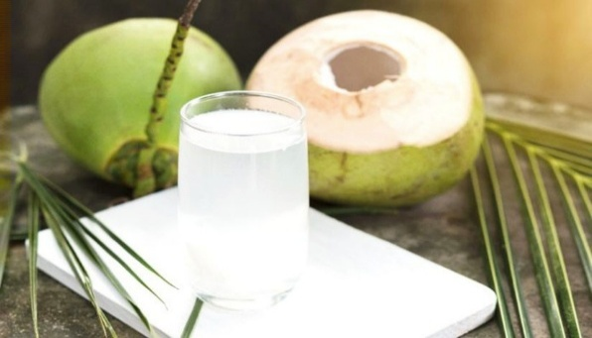
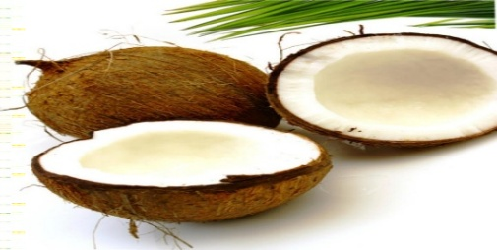
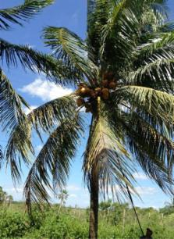
- (2)
(3)

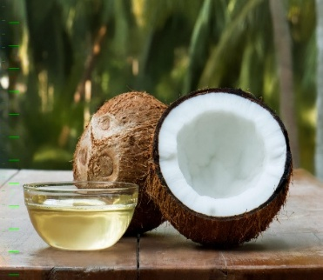
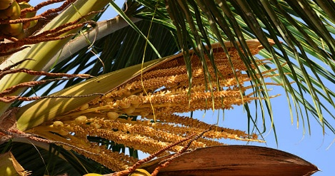
(4) (5)

Fig 1: Various parts and products of Coconut tree (1) Coconut leaf (2) Coconut water (3) Coconut shell (4) Coconut flower (5) Coconut oil
Table 1. Taxonomical Classification of Cocos nucifera L.
Kingdom | Plantae -Plants
Subkingdom | Tracheobionta-Vascular plants
Super division | Spermatophyta-Seed plants
Division | Magnoliophyta _Flowering plants
Class | Liliopsida -Monocotyledons
Subclass | Arecida
Order | Arecales
Family | Arecacede-Palm family
Genus | Coconut palm
Species | Cocosnucifera L. – coconut palm

Coconuts are categorized into two maturity stages such as young and mature. The young coconut takes 6 to 8 months for the formation of endocarp. They often harvested for beverage when maximum volume of coconut water is reached. It is not only refreshing and delicious but also contains many beneficial nutrients such as minerals, sugars, vitamin and inorganic ions as a therapeutic value. The potential of young CW has been Student for elderly people and children with gastroenteries as it acts as an oral rehydration fluid. It also has been reported that coconut water used as a substitute for loss of fluid by diarrhoea patient.
Mature coconuts are formed endocarp, between 11 and 18 months often harvested for their albumin or flesh which is usually further processed into coconut milk, coconut cake and coconut flask. In most cases coconut water from mature coconut is discarded however it is still drinkable and possesses. many functional electrolytes and sugar which is beneficial to consumes. Nowadays there is growing awareness about benefits of natural drink. Many manufacturers are seeking natural alternative as coconut water emerging as a popular alternative drink as it contains ergogenic acid which is easily obtained from tropical regions [6].
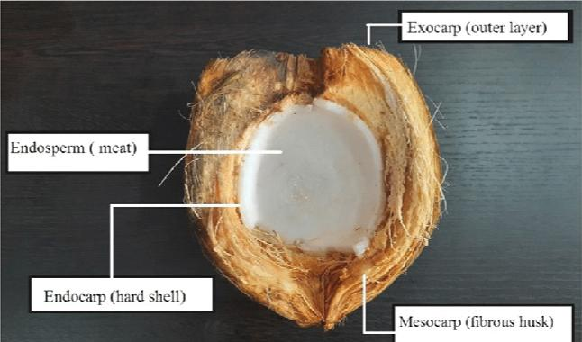

Fig 2: Various Parts of coconut
All parts of coconut tree are used as food and commercially as they are rich in medicinal properties. They have ayurvedic medicine properties for treating various clinical conditions. The part of its fruit like coconut kernel and tender coconut water has numerous, medicinal properties. It includes antibacterial, antifungal, antiviral, antiparasitic etc. It also contains microminerals, and nutrients which are essential to human health. Hence the entire tree has various medicinal properties, the coconut tree is often referred as Kalpavriksha [18].
2.PHYTOCHEMICAL SCREENING OF COCONUT:
2.1Coconut water:
Coconut water is a rich source of nutrient including key amino acids such as lysine, leucine, phenylalanine, tyrosine, histidine and tryptophan, palmiticoleic acid and dietary fiber according to decades of studies. Mineral are also present is significant amount The most important sugars are glucose sucrose and fructose. It contains prevalent such as Tartaric acid citric acid and malic acid this acid are organic in nature vitamin B1, B2 and vitamin C are also present [12].
Lobo et al., (2021) evaluated the phytochemical screening of coconut water of green and yellow variety alkaloid and reducing sugar were abundant in yellow variety than green variety, flavonoid absent in both species. In the view of saponin, tannins and steroids were also on higher percentages in yellow variety [12].
Afunwa et al., (2025) evaluated phytochemical analysis of coconut water sample showed that saponin, flavonoid and steroid are highly present glycoside was detected in minute quantity other secondary metabolites like terpenes, tannins and amino acid were not present [1].
2.2Coconut Leaf:
Agnihotri et al., (2021) investigated the phytochemical analysis of methanol extract of Cocos nucifera leaf showed saponin, tannin, alkaloids and cardinal glycosides were present whereas flavonoid, protein, arthraquinones, were absent [3].
Islam et al., (2019) evaluated the phytochemical screening of methanolic extract of Cocos nucifera leaves, the result showed that presence of flavonoids, phenols, saponins, terpenoids and triterpenes. Alkaloids, glycosides and tannins, were moderately present. Quantitative evaluation of coconut leaves shows phenol concentration are higher than tannin [16].
2.3 Coconut Flower:
The phytochemical screening of flower shows the presence of alkaloid, flavonoids, Phenol, phytosterol, amino acids and carbohydrates. These phytochemicals have more effective against several human pathogen [18].
Nagappan et al., (2021) evaluated the phytochemical analysis of Cocos nucifera flower showed that coconut flower contains carbohydrates, flavonoid, tannins, glycosides, protein and amino acids. It does not contain alkaloid, saponins and phytosterols [15].
2.4 Coconut oil:
Coconut oil appears colourless liquid at 30 °C and above. The colour of solidified coconut oil at 25°C is a white. The smoking point of refined coconut of is 232°C and unrefined coconut oil is 179°C. Coconut oil is drained from coconut fruit as it contains cupric acid and lauric acid which axe medium chain fatty acid. It has been used in various application such as cosmetics, detergent production. It also has numerous health benefit due to its high saturated fat content [5].
Jaji et al., (2024) evaluated qualitative and quantitative phytochemical Screening of sample from Cocos nucifera shows the Coconut oil contain secondary metabolites such as Saponins, flavonoid whereas tannins, terpenoids, glycosides and steroids are not present in Coconut oil [7].
2.5 Coconut Shell and Coir:
Coconut coir is a part of mesocarp layer contains secondary metabolites that have the potential as antimicrobial agents. Coconut coir and shell have the potential to developed as a new medicinal ingredient for treating diarrhea [14].
Misrahanum et al., (2020) investigated the qualitative phytochemical greening of coconut coir and shell showed that secondary metabolites like flavonoid, tannin, saponin were present whereas alkaloid, steroid and terpenoids were not present [14].
Karseno et al., (2023) evaluated, Phytochemical analysis of coconut coir of both young and old coir, the result showed that young coconut coir extract has tannins, flavonoids and steroids whereas old coconut coir has tannins flavonoids, steroids and terpenoids [9].
Table 2. Phytochemicals of Various parts of Cocos nucifera
Photochemical | Coconut  water  Afunwa et al.,  (2025) | Coconut leaf Agnihotri et al., (2021) | Coconut flower  Nagappan et al., (2021) | Coconut oil  Jaji et al., (2024) | Coconut shell and coir  Misrahanum et al., (2020)
Saponin | + | + | - | + | +
Tannin | - | + | + | - | +
Flavonoid | + | - | + | + | +
Steroid | + | + | - | - | -
Alkaloid | - | - | - | - | -
Terpenes | - | + | - | - | -
Glycoside | - | + | + | - | -
Amino acid | - | - | + | - | -
Carbohydrate | - | - | + | - | -
3. ANTIMICROBIAL PROPERTIES OF COCONUT:
3.1 Coconut water:
Anyiam (2023) evaluated the antimicrobial activity of coconut water on four different microorganisms showed that coconut water exhibits strong antimicrobial activity against both gram Positive and gram-negative bacteria such as Klebsiella spp, Pseudomonas aeruginosa, Staphylococcus aureus and Escherichia coli. It showed clear antibacterial effects especially at concentration 60mg/ml [4].
Agila (2022) investigated antibacterial activity of young Cocos nucifera water the result shows that the extract was effective against gram positive bacteria Streptococcus. Hence coconut water as used for treatment against oral infection causing bacteria [2].
Lamy et al., (2023) evaluated the antibacterial activity of coconut water on four bacteria. By transformed the coconut water into a medicinal syrup and tested in both liquid and solid media. The test result showed that only two organisms Staphylococcus enteritidis and Staphylococcus dysenteriae have susceptibility at 0.25 10ml of both MIC and MBC whereas Acinetobacter Baumannii and Escherichia Coli are not suspectable [10].
3.2 Coconut Leaves:
Antimicrobial property of coconut leaf extract against Acinebacter spp., Bacillus Cereus, Aspergillus flavus and Aspergillus niger shows active against all organism except Staphylococcus aureus and Aspergillus flavus. Antibacterial activity of 26 medicinal plants was evaluated with aqueous and methanolic extract, result showed that coconut is one among them which shows a strong bacterial activity against tested species [18].
Silva et al., (2013) investigated the antimicrobial properties of Cocos nucifera leaf on Staphylococcus aureus, Candida albican, Escherichia coli and methicillin resistant Staphylococcus aureus highly. The result showed that it was effective against Staphylococcus aureus and MRSA at 102μg/ml concentration [19].
3.3 Coconut Flower:
Vaduvi et al., (2021) investigated the antimicrobial properties of cocosnucifera flower son two type of extract such as ethanol and chloroform. The result shows that it was strongly effective against Staphylococcus aureus and also effective against another species of Staphylococcus. Antibacterial activity is ineffective against Bacillus, Escherichia coli and Salmonella in ethanol extracts are whereas in Chloroform extract it shows antimicrobial activities against Escherichia Coli, Enterococcus faecalis and not effective in salmonella [21].
Raja et al., (2015) investigated antimicrobial properties of Cocos nucifera female flower of both fresh and dried flower powder on Escherichia coli, Staphylococcus aureus and Bacillus subtilis. The result shows that it has strong antimicrobial activity in fresh flower than dried ones in most test organism [17].
3.4 Coconut Oil:
Lauric acid is a natural compound that is mainly present in coconut oil and also residues in human breast milk studies have been done to detect the potentiality of Lauric acid against many harmful pathogens [18].
Jaji et al., (2024) investigated the antimicrobial properties of coconut oil with different bacteria and fungi. The result shows that effective against almost tested organism except Bacillus subtilis and Salmonella typhi which showed reduced sensitivity even at 500mg/ml concentration Pseudomonas aeruginosa and Penicillium shows more inhibition at 250-500mg/ml. At 1250mg /ml no activity was recorded which indicate inhibition level increases with increase concentration [7].
Kanu et al., (2023) evaluated the antibacterial activity of coconut oil and water. The result shows that Bacillus spp has the greatest activity to coconut oil, while Escherichia coli shows susceptibility and Pseudomonas auroginosa exhibit resistant [8].
3.5 Coconut Shell and Coir:
Mazaya et al., (2020) investigated the antimicrobial activity of coconut shell extract against Acetobacter aceti, Saccharomyces cerevisiae and indigenous microbes of broken coconut sap. The result show that the extract less effective against Acetobacter aceti and Saccharomyces cerevisiae are more resistant at all concentration. Sap microbes are moderately resistance; this is possible because the yeast Saccharomyces cerevisiaec an survive with Acetobacter aceti bacteria [13].
Ukoama et al., (2024) evaluated the antimicrobial activity of coconut husk on four different organisms The result show that coconut husk effectively inhibits the growth of Escherichia coli and S. aureus by creating a clear zone of 18.7mm for Staphylococcus aureus and Escherichia coli of 15.5mm zone of inhibition. It also shows Salmonella typhi (17.8 mm zone) and Candida albicans (15.5mm zone) [20].
Karseno et al., (2023) investigated the Phytochemical and antimicrobial activity of coconut coir extract on various solvent the result showed that both young and old coir extract showed antimicrobial activity against Saccharomyces cerevisiae, Acetobacter aceti and also fermented rap like Saccharomyces spp, Actinobacteria, Sarcina, Leuconatou, Brevibacterium, Serratia and Pediococcus old coconut coir shows more antimicrobial activity than young coconut coir antimicrobial activity against all tested organism [9].

4.CONCLUSION:
Cocos nucifera is an extremely valuable tropical plant that has important industrial, medical, and nutritional uses. Many bioactive compounds, including flavonoids, saponins, tannins, phenolic compounds, and glycosides, can be found in the coconut tree's water, leaves, flowers, oil, shell, and coir. These phytochemicals support the plant's various biological processes. Study examined in this article shows that extracts made from various coconut components have antibacterial effects against a variety of pathogenic microorganisms, including certain fungi and both Gram-positive and Gram-negative bacteria. The plant part, extract protocol, and concentration all influence how effective an antibiotic is. All things considered, the results demonstrate Cocos nucifera's potential as a natural source of antibacterial compounds that might aid in the creation of substitute pharmaceuticals.
REFERENCES:
[1] Afunwa, R. A., Okafor, C. M., Igboko, C. A., Noofia, M. C. N., Gbadamasi, A. And Mgbodile, F. C. 2025. Phytochemical and antimicrobial properties of coconut water (Cocos nucifera L.) against bacterial isolates from students’ urine samples. ISRG Journal of Clinical Medicine and Medical Research: 304–310.
[2] Agila, S., Fathima, S. 2022. Antimicrobial activity of young Cocos nucifera (coconut) water against oral infection-causing bacteria. International Journal of Trend in Scientific Research and Development.6(4), pp:950-954.
[3] Agnihotri, I. M., Chari, S. S. And Kadam, D. G. 2021. GC–MS analysis and antibacterial activity of Cocos nucifera and Musa acuminata against multidrug-resistant Escherichia coli and Staphylococcus aureus. World Journal of Pharmaceutical Research, 10(4): 1204–1217.
[4] Anylam, I.V. and Opara, C.N., 2023. Phytochemicals and antimicrobial activity of coconut water (Cocos nucifera) on microbial pathogens. GSC Biological and Pharmaceutical Sciences, 25(2), pp.273-282.
[5] Bello, O.O., Akande, R.O., Bello, T.K., Fashola, M.O., Oni, M.O. and Osho, A., 2025. Phytochemical and Antifungal Evaluations of Virgin Cocos nucifera (Coconut) Oil. OBM Integrative and Complementary Medicine, 10(1), pp.1-15.
[6] Halim, H.H., Williams Dee, E., Pak Dek, M.S., Hamid, A.A., Ngalim, A., Saari, N. And Jaafar, A.H., 2018. Ergogenic attributes of young and mature coconut (Cocos nucifera L.) water based on physical properties, sugars and electrolytes contents. International Journal of Food Properties, 21(1), pp.2378-2389.
[7] Jaji, B.A., Oloruntele, I.O., Sekoni, H.A., Ibrahim, M.M. and Adeoye, S.O., 2024. Characterisation and evaluation of physicochemical properties, phytochemicals and antimicrobial analysis of coconut oil. Dutse Journal of Pure and Applied Sciences, 10(3b) :124-137.
[8] Kanu, U.J. and Obi, C.P., Phytochemical analysis and Antibacterial activities of Coconut oil and water on Some Bacteria. 5(2), pp.1-5
[9] Karsono, P., Haryanti, P. And Poetri, R.K., 2023, April. Phytochemical Characteristic and Antimicrobial Activity of Coconut Coir Extract on Various Solvents. In 3rd International Conference on Sustainable Agriculture for Rural Development (ICSARD 2022) (pp. 169-182). Atlantis Press.
[10] Lamy, G. M., Likeng, J. L. N., NDTB, R. C., NOC, S. E., Africaine, N., Elmo, B., Buh, S. M. M., Sandra, L., Biyon, M. J. B. N., Harmen, K., Narga, E. N. And Tchindra, A. J. A. 2024. Ethnomedicine and antibacterial activity of Cocos nucifera water on four bacterial strains in Centre Cameroon. Asian Journal of Natural Products and Biochemistry, 22: 21–24.
[11] Lima, E.B.C., Sousa, C.N.S., Meneses, L.N., Ximenes, N.C., Santos Júnior, M.A., Vasconcelos, G.S., Lima, N.B.C., Patrocínio, M.C.A., Macedo, D. And Vasconcelos, S.M.M., 2015. Cocos nucifera (L.) (Arecaceae): A phytochemical and pharmacological review. Brazilian Journal of Medical and Biological Research, 48(11):953-964
[12] Lobo, A.P., Arpitha, K.V., Shetty, K.D., Rai, S.T., Nayak, P., Kumar, A., Kumar, P. and Pai, A., 2021. Phytochemical and Pharmacological Evaluation of Yellow and Green Variety of Cocos nucifera Water. Journal of Pharmaceutical Research International, 33(51A), 180-186.
[13] Mazaya, G., Karseno, K. And Yanto, T., 2020. Antimicrobial and phytochemical activity of coconut shell extracts. Turkish Journal of Agriculture-Food Science and Technology, 8(5), pp.1090-1097.
[14] Misrahanum, M., Alfiyani, N., Helwati, H. And Sadli, S., 2022. Phytochemical, GC-MS Analysis, and Antibacterial Activity of Ethanol Extract Coir and Shell U Groh (Cocos nucifera L.). Majalah Obat Tradisional, 27(3), pp.172-180.
[15] Nagappan, P., Shagirtha, K., Mary, L.R. and Ramadass, I., 2021. Screening of phytochemical and antioxidant profile of Cocos nucifera flowers in methanol extract. World J. Pharm. Res, 10(9), pp.1160-1171.
[16] Nizami, M. S. A., Hossain, K. M. And Islam, M. S. 2019. Phytochemical screening and in vitro antioxidant and anti-inflammatory potential of methanolic extracts of Cocos nucifera (L.) leaves. Universal Journal of Pharmaceutical Research, 4(2): 14–29.
[17] Raja, J.D. and Poonkuil, N.L., 2015. A study on in vitro antioxidants, antimicrobial, antileukemia activities of Cocos nucifera (coconut) female flowers. 2(10).55-56.
[18] Ramaswamy, L., Rajendran, R., Saraswathi, U., Sughanya, R. And Geethadevi, C., 2015. Antimicrobial properties of Cocos nucifera: a review. Cord, 31(1), pp.1-6.
[19] Silva, R.R., e Silva, D.O., Fontes, H.R., Alviano, C.S., Fernandes, P.D. and Alviano, D.S., 2013. Anti-inflammatory, antioxidant, and antimicrobial activities of Cocos nucifera var. Typica. BMC complementary and alternative medicine, 13(1), p.107.
[20] Ukoma, A. A., Utensils, J. U., Ukachukwu, V. I., Anyika, L. C., Nwogurigwu, N., Umen, S. T., Kenechukwuozie, O. Q., Duru, C. C., Chinakwe, E. C., Nnaadozie, R. I. And Anyanwu, C. O. 2024. Phytochemical composition and antimicrobial activity of coconut husk: A sustainable solution to antimicrobial resistance. African Journal of Biomedical Research, 27(3): 7015–7019.
[21] Vadivu, C.C., Devi, M.P.A., Balakrishnan, V. and Sundari, T., 2020. Phytochemical, antimicrobial and antioxidant studies of (L.) flowers Cocos nucifera. Asian Journal of Pharmacy and Pharmacology, 6(5), pp.337-343.

